HOLLYHOCK | USER & OPERATIONS MANUAL

HOLLYHOCK
User Guide & Operations Manual
Administrator / Office • Caregiver • Client & Family
From first sign-in and client setup through the first completed visit, family access, GPS/EVV review, hours, reports, and day-to-day operations.
Purpose. This book explains how people actually use Hollyhock. It is not a permissions list. Each section tells the user what to open, what to enter, what success looks like, and what to do when the expected result does not appear.

Coal Road Productions
Hollyhock Developer Pack • User & Operations Manual • Version 1.0 • October 2026
Companion volume: Hollyhock Server Installation & Field Operations Manual — Technician Edition

READ THIS FIRST

Welcome to Daily Hollyhock Operations
Hollyhock keeps care operations together: leads, consultations, clients, offices, caregivers, schedules, family access, visit evidence, CARE-GPS, hours, review, reports, and the web/mobile tools that connect them. The practical rule is simple: use the workflow that belongs to your role and let each important action finish in a clear state.
No permanent default passwords. An authorized administrator or facilitator supplies a temporary login or invitation. Each person uses their own account. Never print or reuse a permanent shared password in this manual.

Manual and Release Compatibility Record
Record the release identifiers used by the customer. If the screen wording differs materially from this manual, the packaged release notes control. Do not invent a button or permission that the installed release does not provide.
Component | Validated version / identifier | Check
User & Operations Manual | Version 1.0 | This document
Hollyhock server release | ________________________ | Match MANIFEST / release notes
Database/schema level | ________________________ | Match release notes
Caregiver Android app | ________________________ | Match approved package
Client & Family Android app | ________________________ | Match approved package
Primary office / timezone | ________________________ | Customer setting

The operating rule: no mystery states
A user should be able to tell whether work is saved, pending, assigned, on the way, arrived, clocked in, clocked out, awaiting review, approved, denied, exported, or complete. If a screen is ambiguous, stop before repeating the action and use the troubleshooting section. Repeated taps can create confusion even when the server correctly rejects duplicates.

Guide Map
This manual is organized by the person doing the work. Start with your role and use the end-to-end workflow when training a whole office.
Part I — Administrator / Office
Daily office operations: dashboard, offices, leads, consultations, clients, verified service locations, scheduling, people, family access, messages, documents, GPS Review, hours/corrections, reports, analytics, and mobile app distribution.
Part II — Caregiver
Android setup, phone readiness, My Day, visit preparation, Approach, arrival, clock-in, on-duty work, requests/messages, clock-out, open shifts, availability, credentials, mileage, administrative work, and recovery after interruptions.
Part III — Client & Family
Invitation/access, Android installation, first login, Home, Visits, Household Requests, Messages & Notices, privacy, offline behavior, and the office walk-through script.
Part IV — Complete Visit Workflow
New client → verified pin → scheduled visit → caregiver assignment → Approach → arrival → clock-in → care → clock-out → office review.
Part V — Troubleshooting & Quick Reference
Plain-English recovery paths, privacy/role matrix, training sign-off, and one-page quick starts for every role.

Role Boundaries at a Glance
Role | Normal work | Must not receive by default
Organization / Office Administrator | Authorized offices, leads, consultations, clients, schedules, staffing, family access, GPS review, hours/corrections, reports, mobile app administration. | Access outside authorized office/organization scope.
Caregiver | Own assigned visits, Approach/arrival/clock actions, own work records, requests/messages, approved assigned-client information. | Finance, user/role administration, other caregivers' private records, unrestricted client roster.
Client & Family | Information for the linked client, visit status, household requests, messages/notices, own account/privacy information. | Live caregiver tracking, raw GPS evidence, payroll, caregiver device trust, other clients or staff administration.

Privacy rule. Family visit status is not a live map of a caregiver. The family side should show understandable status and communication without exposing raw GPS samples, payroll information, device-trust details, internal identifiers, or other clients.

PART I
Administrator / Office Operations
Use this section for the people who run the agency day to day: owner, office administrator, scheduler, reviewer, or another authorized staff user. Screens are scoped by office and role. If a user cannot see a module, confirm the person’s role and office mapping before treating it as an application failure.

1

Sign In, First Password, and Office Context
Each administrator signs in with an individual account. The installed customer release may use an invitation, a temporary password, or a first-login reset. The important part is that the final credential belongs to one human being, not to the office as a shared secret.
1. Open the customer Hollyhock application address in a supported browser.
2. Enter the administrator email supplied by the authorized facilitator or owner.
3. Enter the temporary password or complete the invitation flow. If Hollyhock asks for a new password, create it before continuing.
4. Sign out once and sign back in with the new private password. This proves the credential is usable before real data entry begins.
5. Look at the organization and office shown in the application shell. If you are authorized for more than one office, use the office selector before creating or editing records.
6. If the wrong office appears or no office is available, stop. Have an organization administrator correct the office mapping rather than creating duplicate clients in the wrong office.
What success looks like. The correct organization/office is visible, the dashboard loads, and the navigation only contains modules this user is authorized to use.

2

Overview Dashboard and Daily Triage
The Overview page is the office command center. Use it first to understand what needs attention before opening individual modules. Current builds can surface pipeline counts, overdue follow-ups, consultation activity, notifications, and schedule/visit issues.
1. Open Overview after sign-in.
2. Read the summary counts before opening individual records. Look for overdue follow-ups, open schedule problems, unread notifications, or visit exceptions.
3. Open the item that needs action from the dashboard or the left navigation.
4. Return to Overview after clearing a problem to confirm the count or state changed as expected.
5. Do not use the dashboard count as a substitute for reviewing the underlying record when a visit, hour, or GPS exception affects billing, payroll, or client service.
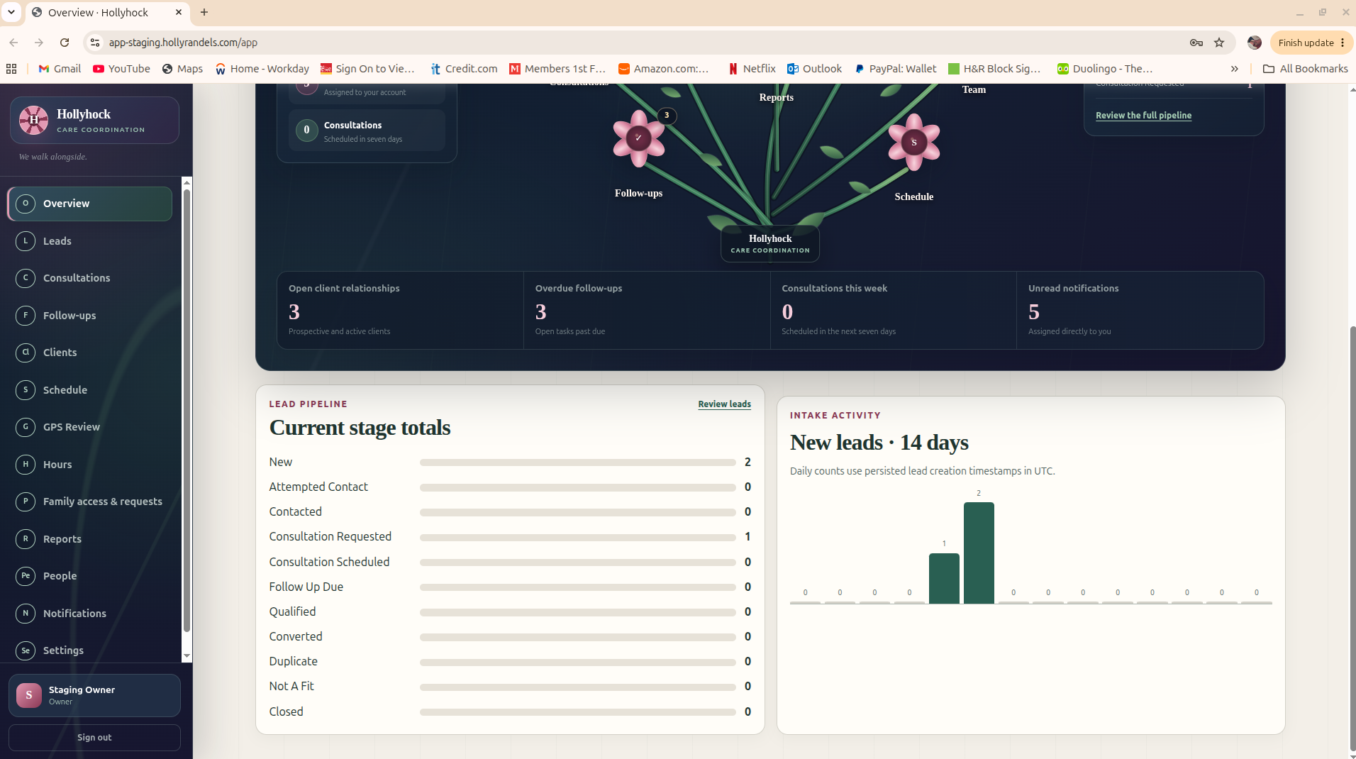
Administrator reference: Overview and the left-side operational navigation.
3

Leads, Intake, Consultations, and Follow-Ups
A prospective client should move through Hollyhock instead of being retyped into separate lists. The objective is to preserve the person, contact information, service need, referral history, consultation work, and conversion path as one operational record.

Create a lead manually
1. Open Leads and choose Add a Lead / New Lead.
2. Enter the lead or household name, primary contact, relationship, preferred contact method, phone, and email.
3. Enter the service address if it is known. If the care location is different from the contact address, record the service address separately when the form allows it.
4. Add the care need, timing, referral source, and useful notes. Keep medical or highly sensitive material out of a general lead note unless the customer’s policy specifically permits it.
5. Save the lead. Re-open the lead once to confirm the contact information and current pipeline stage were saved.

Schedule a consultation or follow-up
1. Open the lead and choose the consultation or follow-up action available in the installed release.
2. Set the date/time, responsible staff member, contact method, and short purpose.
3. Save. Confirm the consultation/follow-up appears in the responsible user’s work queue.
4. After the contact occurs, record the result and next action. Do not leave a finished consultation looking like an overdue future task.

Convert the lead to a client
1. Open the qualified lead and choose Convert / Create Client.
2. Review the information that will carry forward. Correct spelling or contact details before conversion rather than fixing two records later.
3. Complete the conversion. Open Clients and confirm the new client exists with the expected source/contact information.
4. Continue client setup with the service location and verified GPS pin before scheduling field visits.
4

Clients and Service Locations
The client record is the operational anchor for service. A field visit must point to the right client and the right service location. For CARE-GPS, a good street address is not enough by itself; the verified pin must represent the actual approved place where care begins.

Create or edit a client
1. Open Clients. Choose New Client, or open an existing client.
2. Enter or review the client’s name, contact information, status, office, and service-related details available in the release.
3. Save before adding a service location if the screen separates these steps.
4. Re-open the client and confirm the status and office are correct.

Add the service location and drop the verified pin
1. Open the client’s Service Location / Location section and choose Add Location or Edit Location.
2. Enter the complete service address. Use apartment/unit information in the address fields, but place the map pin on the actual entrance or approved service point whenever the map supports that level of precision.
3. Move or drop the map pin to the approved location. Zoom in enough to distinguish the correct building/entrance from the street or a neighboring property.
4. If the release allows a service radius, enter the customer-approved radius. Older CARE-GPS test guidance used 100 yards for early testing; production values should follow the agency’s current policy and release configuration.
5. Save the location. Confirm the client/location card shows the pin as saved or verified.
6. Open the saved location again and visually confirm the pin did not jump to a street centroid, ZIP code center, or neighboring address.
7. If the client receives care at more than one place, create separate service locations instead of repeatedly moving one pin.
Do not “fix” GPS by moving the pin to the caregiver. The verified pin represents the authorized service location. If a caregiver is legitimately elsewhere with the client, use the approved alternate-location/exception workflow rather than falsifying the client’s home location.

5

Schedule Visits, Assign Caregivers, and Publish Work
Scheduling is where a client, service location, caregiver, time window, and operational notes become one visit. A draft is not the same thing as a published/assigned visit.
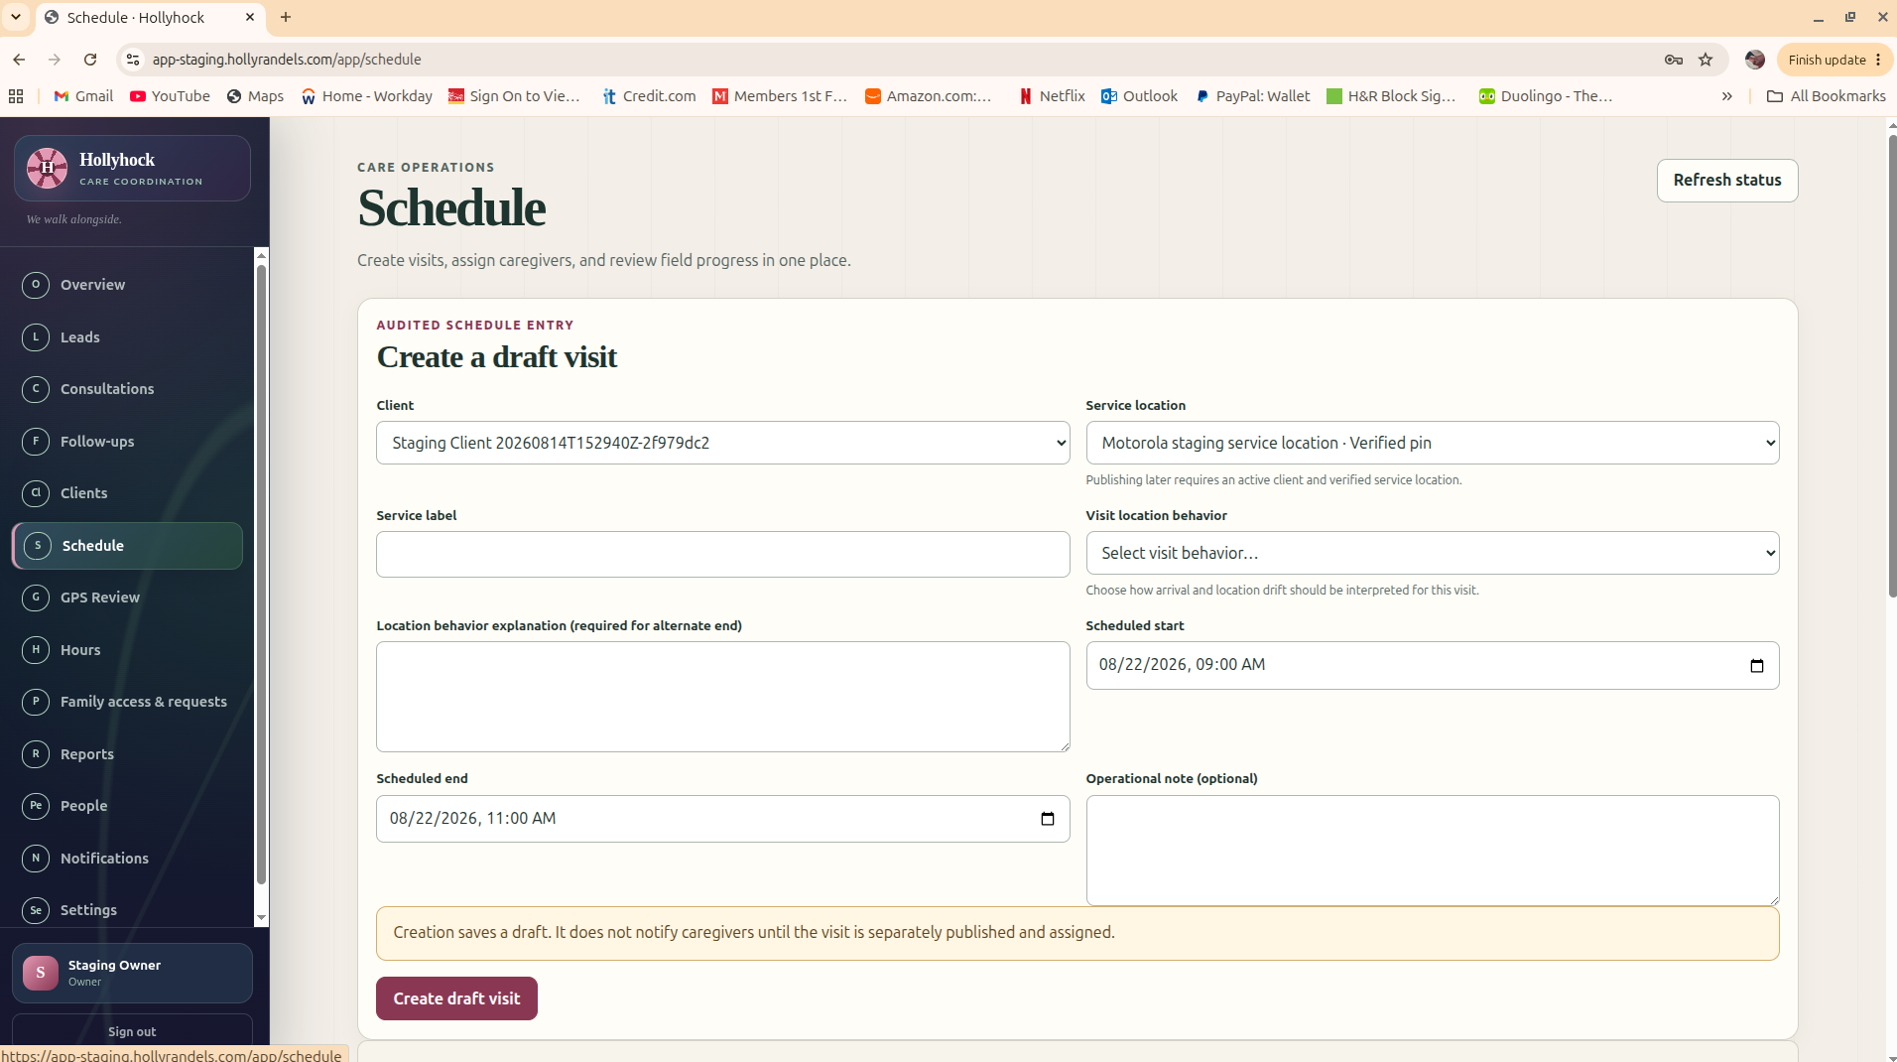
Administrator reference: Create a draft visit. Draft creation does not, by itself, notify a caregiver.

Create the visit
1. Open Schedule and choose Create Visit / Create Draft Visit.
2. Select the client and the correct service location.
3. Enter the service label/type and any location behavior or explanation the release requires.
4. Set the scheduled start and end in the office’s local timezone. Check AM/PM carefully.
5. Add an operational note only if it belongs with this visit. Avoid placing unrelated sensitive information in the schedule card.
6. Create the draft. Confirm the visit appears on the schedule with the expected date and time.

Assign and publish
1. Open the draft visit.
2. Assign the intended caregiver, or mark the visit open if the release supports open-shift workflow.
3. Publish/confirm the visit so it becomes visible to the caregiver application.
4. Verify the visit state changed from draft/open to the expected assigned/published state.
5. When possible, have the caregiver refresh My Day and confirm the visit is visible before the person leaves for service.

Call-off, cancellation, and replacement
1. Open the existing visit; do not create a second visit just to record a call-off.
2. Choose the appropriate call-off/cancel/coverage action available in the release and record the reason.
3. If a replacement is found, assign the replacement to the same visit or follow the release’s replacement workflow.
4. Confirm the original caregiver no longer sees the visit as an active assignment and the replacement does.
5. Check Notifications/Messages if the workflow is expected to notify one or both caregivers.
6

People, Roles, Caregiver Readiness, and Office Access
People management is not just a contact list. It controls who can enter the application, which office they belong to, which role bundle they have, and whether a caregiver is ready to receive work.
1. Open People or Settings → People, Roles & Permissions.
2. Choose Invite a Person / Add Person. Enter the person’s real work email.
3. Assign the organization/office membership and the correct role bundle. Use the least authority that lets the person do the job.
4. For a caregiver, create or confirm the caregiver profile/code and set readiness to the appropriate state.
5. Send the invitation or temporary-login instructions. Require the person to complete their own password setup.
6. After acceptance, return to People and confirm Account, Membership, Role, and Caregiver Readiness all show the intended state.
7. To suspend a user, use the account/membership control in Hollyhock. Do not “disable” someone by changing the email address or sharing a new password.
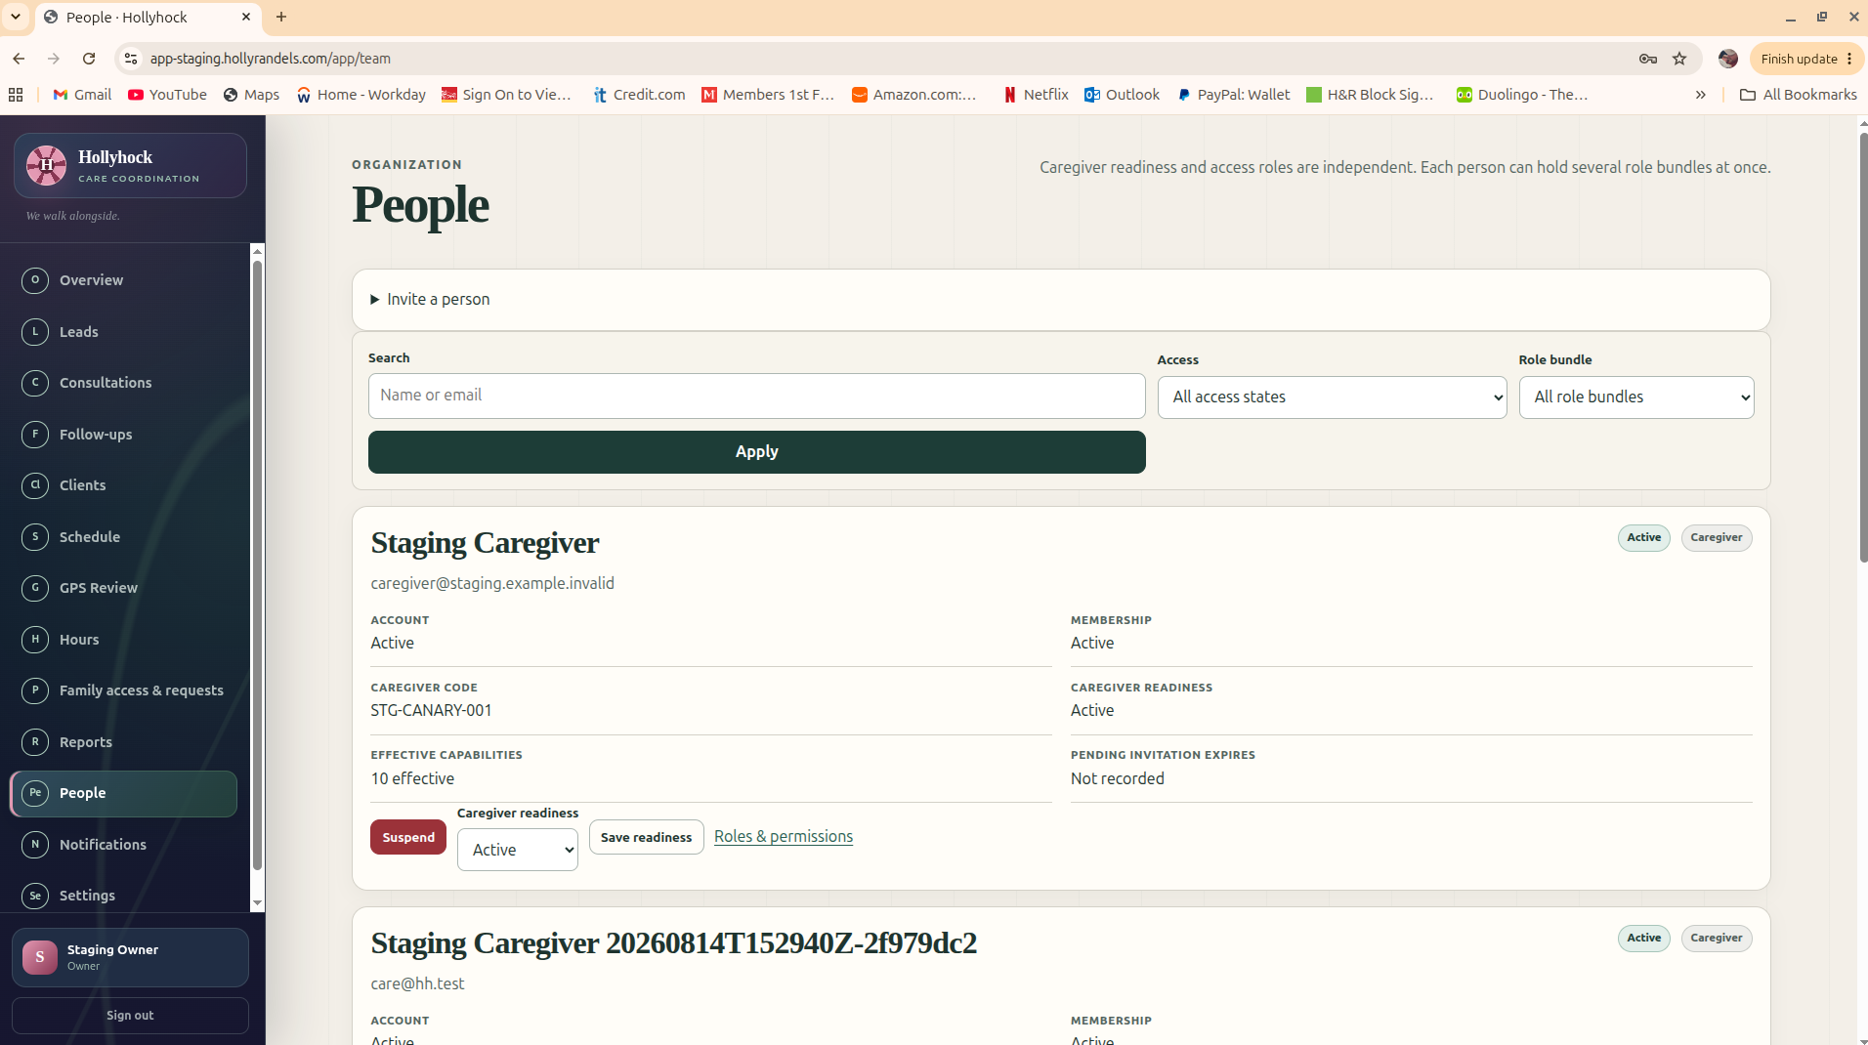
Administrator reference: People page with account, membership, caregiver readiness, capabilities, and invitation state.
7

Family Access and Household Requests
Family access is attached to a client. Create the client first, then grant the family member access to that client. A family identity should never inherit staff or caregiver authority.
1. Open the client, Family Access & Requests, or the family-access section used by the installed release.
2. Choose Add Family Contact / Invite Family Member.
3. Enter the family member’s name, email, relationship, and the client they are permitted to see.
4. Confirm the grant is limited to the intended client. Do not grant a family identity staff, caregiver, CARE-GPS, hours, payroll, device, or administrative capabilities.
5. Send the invitation or temporary login. Tell the family member that the final password is theirs and should not be shared with office staff.
6. After the person signs in, confirm the access state is active and the linked client is correct.
7. Use the Household Requests queue to review requests submitted from the family app. Move the request through the human states offered by the release, such as Submitted → Acknowledged → Completed.
8

Messages, Notices, and Notifications
Hollyhock messages are operational communication. Keep the message tied to the correct person, visit, request, or office work item whenever the screen offers that relationship.
1. Open Notifications or the applicable Messages area.
2. Read unread items first. Pay attention to assignment, open-shift, cancellation, request, and visit exception notices.
3. Open the underlying record before acting on an alert that changes schedule, time, or GPS review.
4. Mark messages read after the action is understood or completed; do not clear a notification merely to remove a badge.
5. For urgent safety or medical emergencies, use the agency’s emergency process. In-app messaging is not a substitute for 911 or an emergency call tree.
9

Documents and Record Visibility
Document features are release-gated. If the customer’s build includes Documents/Document Center, use it as an operational record store, not as an unstructured dump. If the installed release does not expose Documents, skip this section and follow the customer’s approved document process.
1. Open Documents / Document Center.
2. Choose Upload or Add Document and select the correct client/person/visit relationship.
3. Set the category, description, visibility, and reviewed state offered by the release.
4. Upload the file and wait for a saved/complete state before leaving the page.
5. Re-open the document. Confirm the title, related record, uploader, timestamp, and visibility are correct.
6. Do not expose internal staff-only material to family/caregiver roles unless the release’s visibility control explicitly permits it.
10

GPS Review: Verify Evidence, Not Hunches
CARE-GPS does not silently turn every location reading into payroll time. The office review side exists because real devices, buildings, alternate service locations, timing windows, and interruptions can produce exceptions. Review the evidence and the visit state together.
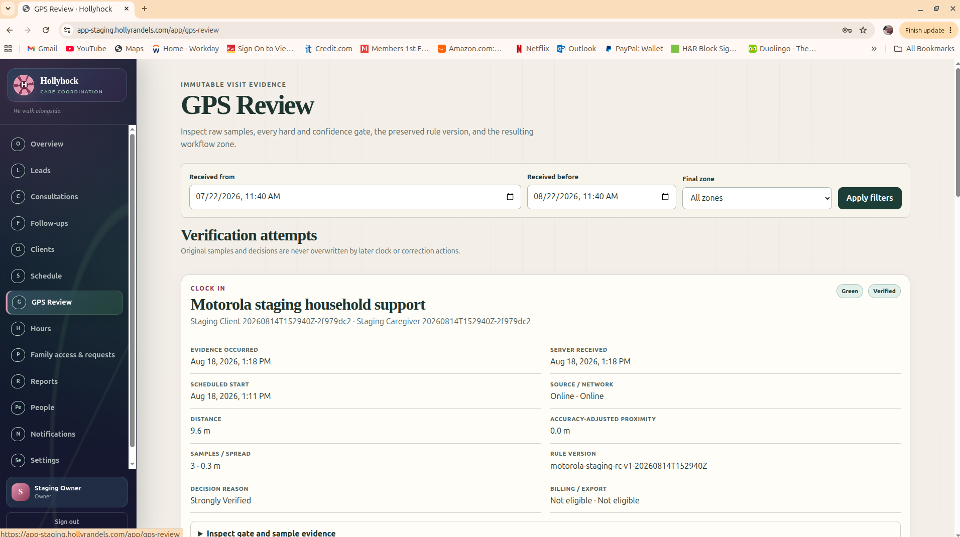
Administrator reference: a verified GPS attempt with evidence timing, distance, samples, rule version, and decision state.
1. Open GPS Review. Filter by date, office, decision/zone, or review state as needed.
2. Open the verification attempt. Confirm the visit, caregiver, scheduled time, client/service location, and decision all belong together.
3. Review the evidence fields shown by the release: distance, reported accuracy/uncertainty, sample count/spread, timing, source, rule version, and any note or exception reason.
4. If the decision is verified and no review is required, leave the evidence intact. Do not create a second manual clock event just because you reviewed it.
5. If the record requires review, compare the caregiver evidence with the verified service location and the operational explanation.
6. Approve, deny, or request correction using the authorized review action. Enter a clear reason. The original evidence should remain preserved even when a correction is approved.
7. After the decision, confirm the visit/hours review state changed as expected.
Older CARE-GPS zone labels. Some releases show Green, Yellow, Red, and Blocked. In the older field guide, Green approved automatically; Yellow allowed the clock with later review; Red required a note/review; Blocked required management action. Use the labels and policy in the installed release, not a remembered score from another build.

11

Hours, Corrections, Mileage, and Administrative Time
Clock events produce time evidence; office approval determines what is accepted for downstream use. Hollyhock’s review model is designed so a correction does not erase the original event.

Review visit hours
1. Open Hours / Hours & Review.
2. Choose the date range and office/caregiver filters.
3. Review derived visit hours and any visit exceptions before approving work for export or downstream processing.
4. If the release separates “approved hours” from raw/derived hours, approve only after the visit evidence and correction queue are resolved.
5. Remember that approval may change export/billing eligibility; it does not necessarily transmit payroll, billing, or a claim.

Handle a clock correction
1. Open the pending correction or create the authorized correction from the visit/hours record.
2. Review the original clock facts first.
3. Enter the corrected value and a real reason. Never edit the old evidence out of existence.
4. Approve/deny with the authorized reviewer account.
5. Re-open the derived hours record and confirm the corrected result is visible and the original/correction relationship remains reviewable.

Mileage or administrative work
1. If enabled, open the Mileage or Administrative Work area from the caregiver record or work review queue.
2. Confirm the person, date, category, amount/time, and work-related note.
3. Review or approve according to agency policy. Keep visit hours separate from non-visit administrative time so reporting remains understandable.
12

Reports, Exports, and Analytics
Reports summarize the operational record; they do not replace the underlying evidence. Use reports for management questions and exports only after the underlying visits/hours are in an accepted state.
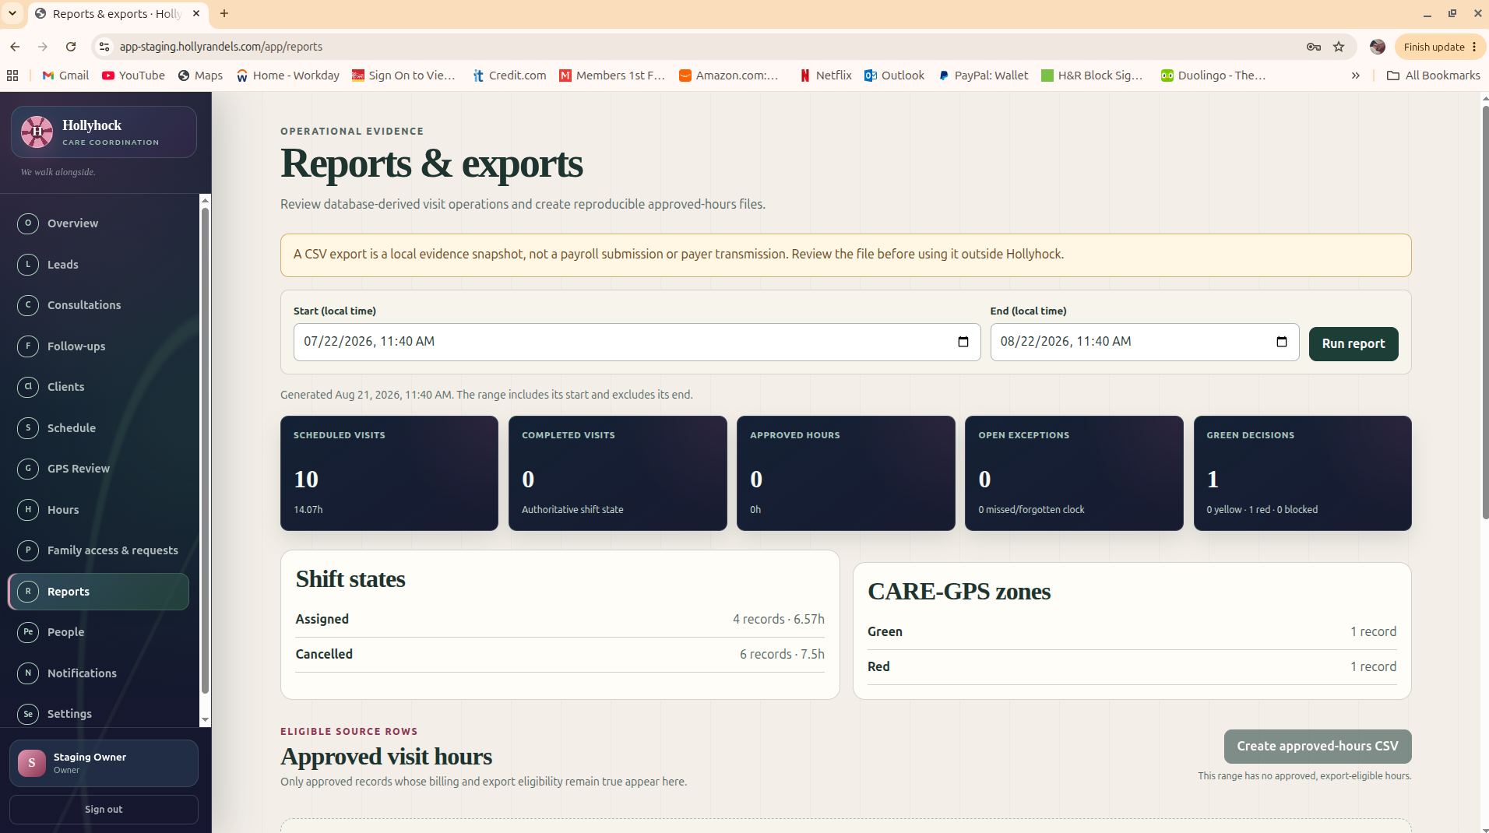
Administrator reference: Reports & exports with visit counts, shift states, CARE-GPS zones, and approved-hours export controls.
1. Open Reports.
2. Set the local-time start and end dates. Confirm the range before running a report.
3. Run the report and review scheduled visits, completed visits, approved hours, open exceptions, shift states, and CARE-GPS summaries offered by the release.
4. Drill into any surprising number before treating it as final. A count of zero can be correct, or it can mean the date range/office filter is wrong.
5. Create an approved-hours CSV only when the release shows eligible approved records. Save the export as part of the office’s controlled workflow.
6. Use Analytics to look for patterns after the underlying records are correct; do not “fix” a trend by altering historical visit evidence.
13

Mobile Apps & Devices and App Downloads
The office may distribute approved Android builds from the authenticated Hollyhock web application before a public app-store listing is used. App distribution is a controlled operation: the server release, app package, signer, and documented release handoff must agree.
1. Open Settings → Mobile Apps & Devices or App Downloads.
2. Confirm the intended Caregiver or Client & Family build is marked available/approved for this customer release.
3. Use the approved download page or customer-specific installation link. Do not email random APK files from a technician’s Downloads folder.
4. After a caregiver installs, confirm the device/install record appears as expected and the account/device state is active.
5. If replacing or suspending a device, use the release’s suspend/revoke/recover controls. Do not create a second caregiver identity simply because the phone changed.
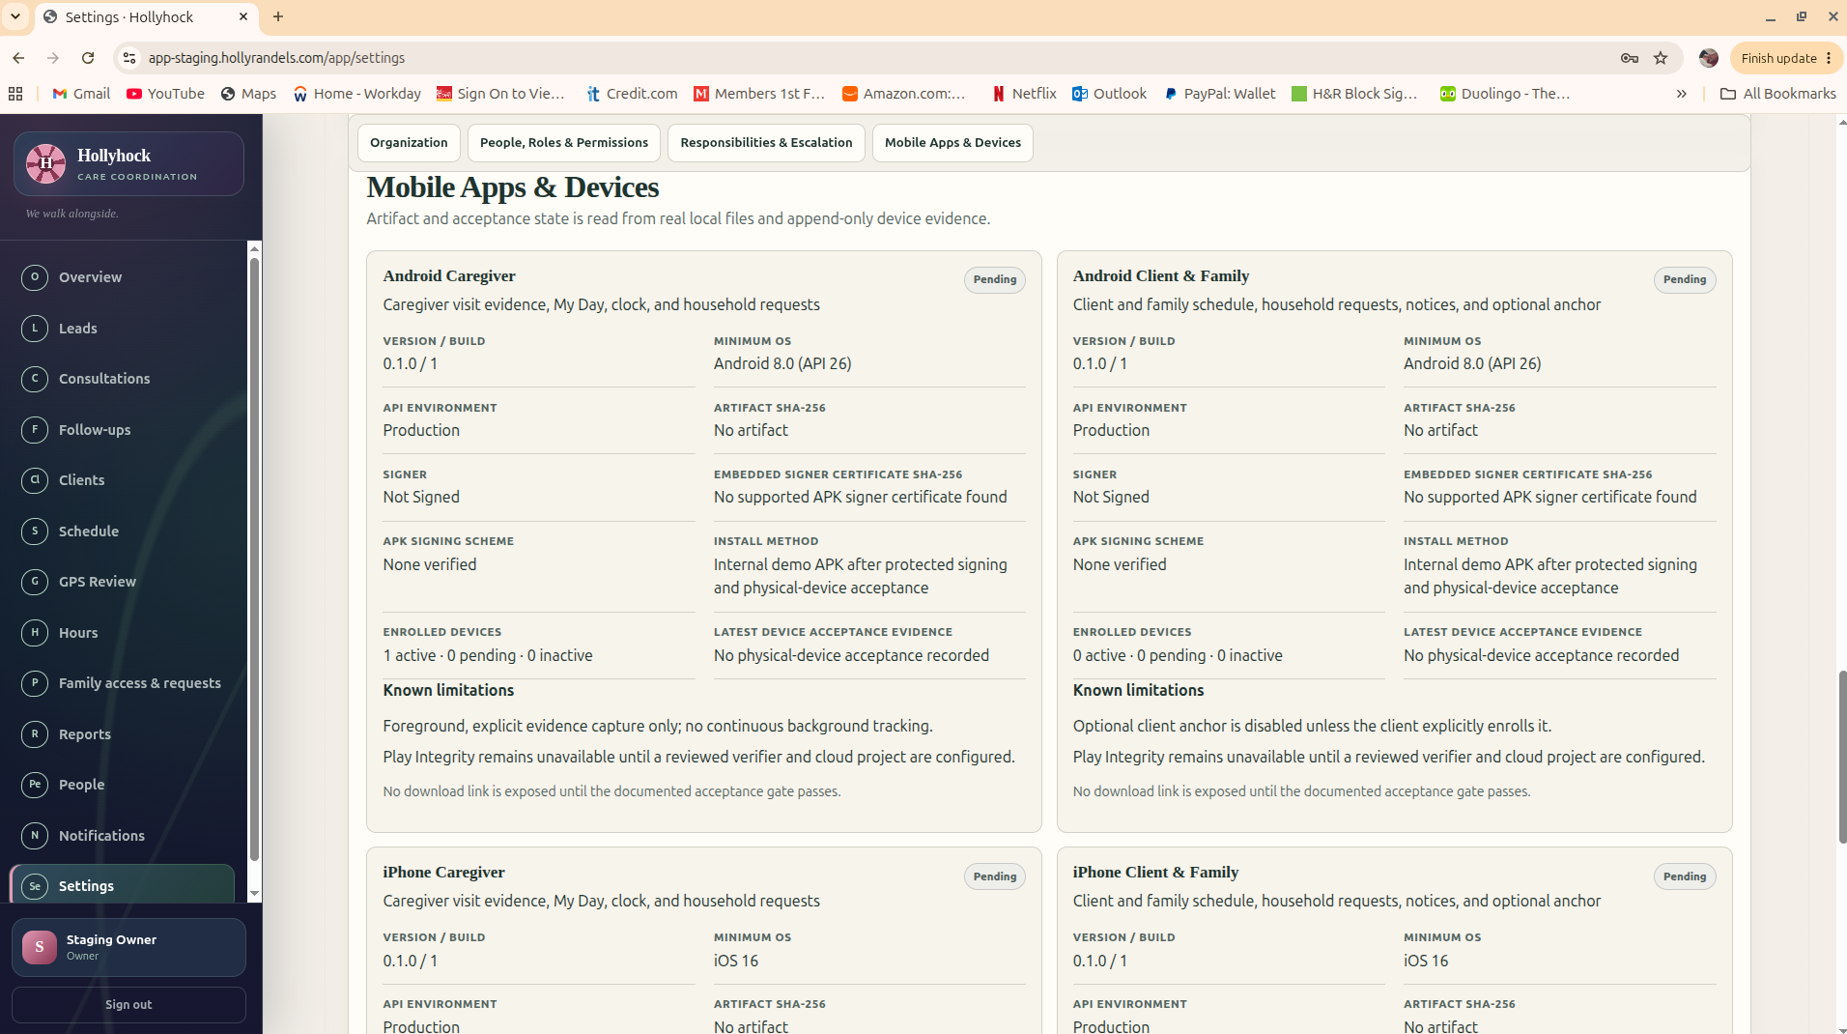
Administrator reference: Mobile Apps & Devices tracks the release status of Caregiver and Client & Family applications.
14

Administrator Daily and Weekly Routine
When | Recommended review
Start of day | Overview → today’s schedule → open visits → call-offs/open shifts → overdue follow-ups → unread notifications.
During day | Schedule changes, caregiver coverage, new leads/consultations, family requests, GPS/visit exceptions requiring action.
End of day | Completed visits, missed clock-ins, unclosed visits, GPS Review, pending corrections, family requests awaiting response.
Weekly | People/readiness, credentials/expirations if enabled, hours approval, mileage/admin work, reports/analytics, unresolved exceptions.
Before export/payroll/billing | Resolve exceptions/corrections; approve hours; verify date range and office; create controlled export only from eligible records.

PART II
Caregiver App
The caregiver app is designed for field work. The caregiver should be able to see today’s work, prepare for a visit, travel with Approach active, confirm arrival, clock in deliberately, document the visit, communicate with the office, and clock out without receiving office-administration or finance authority.

15

Install Hollyhock Caregiver on Android
The office gives the caregiver the approved customer download page or installation link. Do not install a Hollyhock APK from a search result, file-sharing site, or another customer’s package.
1. On the Android phone, open Chrome and go to the customer’s approved Hollyhock download page.
2. Sign in if the download page requires an authorized account, then choose Hollyhock Caregiver.
3. Download the APK. Android may warn that the file came from outside Google Play.
4. If Android asks whether Chrome may install apps from this source, open Settings and allow the installation for this approved file.
5. Return to the downloaded APK and choose Install.
6. If Play Protect says the developer/app is uncommon, verify that this is the approved Hollyhock package. Use More details → Install anyway when appropriate. Do not disable Play Protect globally.
7. Open Hollyhock Caregiver after installation.
Updating the app. Install approved updates over the existing same-signer app unless the release notes specifically say otherwise. Do not uninstall or clear app data just because a new build is available; those actions can remove local state and device enrollment.

16

First Login and Phone Readiness
1. Enter the caregiver email and password. If the Caregiver build asks for an organization code, enter the code supplied by the office; do not guess it.
2. Complete any first-login password step required by the customer.
3. Open More → Phone readiness.
4. Check Visit location / Location services. If it is not Ready, use the on-screen action to open Android settings and allow the location access requested by the approved build.
5. Check Visit alerts / Notifications. Allow visit alerts so assignment, change, arrival, and clock reminders can appear.
6. Check Background activity. If Hollyhock reports Limited or Needs attention, choose Review battery settings and allow the app to operate as required by the customer’s approved configuration.
7. Return to Hollyhock and choose Refresh phone readiness. Do not start travel until the required readiness items are acceptable.
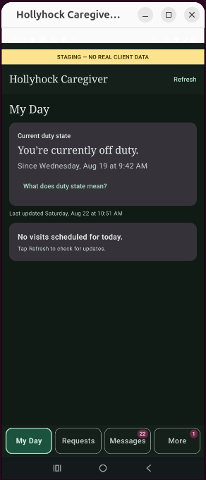  My Day: off-duty state and today’s visits. | 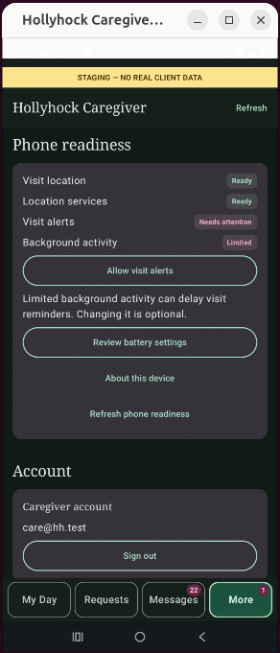  More → Phone readiness: location, alerts, background activity.

17

My Day, Visit Details, and Prepare Visit
My Day is the caregiver’s home base. A caregiver should not have to search the entire agency schedule. The visit shown here should be the caregiver’s own authorized assignment.
1. Open My Day and refresh if the office has just assigned or changed a visit.
2. Open the correct visit. Confirm the client name, service time, and service location before travel.
3. Read any assigned visit notes or household request information visible to the caregiver.
4. Choose Prepare Visit / the visit start preparation action when you are ready to begin the field workflow.
5. If the visit is missing, do not start GPS against another visit. Contact the office and have the schedule/assignment corrected.
18

Start Approach and Travel to the Service Location
Approach is travel awareness, not a hidden payroll clock. It lets Hollyhock collect the location evidence needed to support arrival while the caregiver travels normally.
1. Open the scheduled visit and choose Start Approach when travel toward the service location actually begins.
2. Confirm Hollyhock shows that Approach/travel awareness is active. Keep the phone with you and leave location services on.
3. Travel normally. The app may be in the background; do not force-stop it or swipe it away while Approach is active.
4. If Android shows a persistent Hollyhock location/visit notification, leave it active until the visit workflow ends.
5. As you near the service location, return to the visit if Hollyhock asks you to confirm arrival or recheck the visit.
6. If you intentionally stop travel awareness before arrival, read the resulting state. Approach-only evidence does not automatically create a clock-in.
Important. Approach is evidence that you are approaching the authorized visit. It is not permission to clock in from the road, from a neighboring property, or from a remote location.

19

Arrival and Clock In
1. Arrive at the approved service location and make sure you are actually ready to begin care.
2. Open the visit. Use Recheck Visit / Confirm Arrival / the current arrival action if Hollyhock asks for it.
3. Wait for the location check to finish. Do not repeatedly tap Clock In while a request is still being sent.
4. When Hollyhock offers Clock In, review the client and visit one more time, then clock in deliberately.
5. Wait for the app to show a clear clocked-in / on-duty state before putting the phone away.
6. If Hollyhock allows a reviewed exception, enter a truthful note. If it blocks the clock, contact the office rather than changing the phone clock, moving the client pin, or inventing a location.
Some builds expose distinct Approach-only and full-visit/arrival-handoff modes. If your screen explicitly says Approach only or says that clock-in is not available in that mode, return to the scheduled visit and use the full visit/arrival action. Approach-only should never be treated as a clock event.
20

During the Visit: On Duty, Tasks, Notes, Incidents, Requests, and Messages
1. Confirm the visit remains On Duty / Clocked In.
2. Complete required visit tasks in the visit screen when the release provides them. Mark work only when it is actually completed.
3. Record observations in the correct visit/client field. Keep notes factual and relevant to the service delivered.
4. Use the incident workflow for an actual reportable incident when enabled; follow agency emergency/supervisor procedures in parallel when required.
5. Open Requests to review household requests that the office has made visible to caregivers. A request is not the same thing as a clinical order unless the agency has explicitly made it one.
6. Open Messages for assignment changes, office instructions, or notifications. Use Mark Read after you understand the item.
7. If the app loses network service, keep working under agency policy. Do not sign out, clear app data, or repeatedly create duplicate actions while the device is offline.
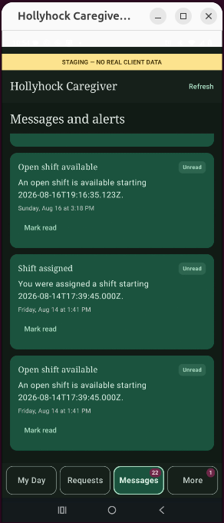
Caregiver reference: Messages and alerts can show assignments, open shifts, cancellations, and unread items.
21

Clock Out and Verify the Visit Closed
1. Before clocking out, finish required visit tasks/notes and confirm you are actually done providing the scheduled care.
2. Open the active visit and choose Clock Out / End Visit.
3. Confirm the action when prompted. If the screen shows a sending/pending state, wait for it to finish before tapping again.
4. Look for a clear completed/clocked-out state and confirm the active duty indicator has ended.
5. Return to My Day. The visit should no longer appear as an active on-duty visit.
6. If your release shows own hours/visit history, confirm the completed visit appears. Report a missing or incorrect time through the correction workflow rather than asking the office to erase the original clock evidence.
Do not leave a visit open overnight. If a clock-out fails or remains pending, use the recovery steps in Part V and contact the office. An unresolved open visit should be reviewed, not silently ignored.

22

Requests, Open Shifts, Availability, Credentials, Mileage, and Administrative Work
These tools are release- and agency-policy dependent. Your app may place them under My Day, Requests, or More → Work. If a customer release does not enable one of these features, do not substitute a different screen.
Feature | How to use it
Household Requests | Open Requests → open the linked request → read the client/visit context → acknowledge/complete only if the app and agency policy allow that action.
Open Shifts | Open the available shift → check date/time/client area → choose the offered/claim/interest action → wait for office confirmation before assuming the shift is yours.
Availability | Open Availability → enter/update the dates/times you can work → save → re-open to confirm. Availability does not itself create an assignment.
Credentials | Open Credentials → review expirations/requirements → upload or provide renewal evidence through the approved workflow. Do not edit an expiration date merely to make a warning disappear.
Mileage | Open Mileage → choose the related work/date → enter the requested mileage/trip information → save/submit. Use actual work travel under agency policy.
Administrative Work | Open Administrative Work → choose category/date → enter time and note → submit. Keep non-visit time separate from client visit clock time.

23

Caregiver Interruption and Recovery
What happened | What to do
Phone locked during Approach | Unlock, reopen Hollyhock, and read the current state. If Approach is still active, continue. If it stopped/expired, use Recheck/Retry only if the visit is still authorized; otherwise contact the office.
App was accidentally swiped away | Reopen it. Do not assume a clock event was created. Confirm the visit state before continuing.
No network | Keep the app installed and preserve local state. Retry/sync when service returns. Do not clear data or reinstall as a first response.
Location says not ready | Check More → Phone readiness, Android location services, and battery/background settings. Confirm the service-location pin with the office if the device is working but the visit never verifies.
Clock-in unavailable after arrival | Confirm you opened the correct visit and used the full visit/arrival path, not Approach-only. Recheck once; then contact the office if the state remains blocked.
Clock-out pending | Wait for the send to finish. If it cannot complete, preserve the screen/state and contact the office. A correction can be reviewed later without deleting the original evidence.

PART III
Client & Family App
The family side is intentionally simpler and more private than the staff side. It shows the linked client’s understandable visit status, household requests, messages/notices, and account/privacy information. It does not expose raw CARE-GPS evidence, payroll, device trust, or other clients.

24

Before the Family Member Installs the App
1. The office creates the client first.
2. The office creates or confirms the family contact and attaches an active access grant to the intended client.
3. The office sends the approved installation link and temporary credential/invitation.
4. The family member should use their own email/account. Do not share a caregiver or office login with a family member.
5. The office should tell the family member what the app is for: visit status, household requests, messages/notices, and account access — not live caregiver surveillance.
25

Install Hollyhock Client & Family on Android
1. On the family member’s Android phone, open Chrome and use the customer’s approved Hollyhock download page/link.
2. Choose Hollyhock Client & Family and download the approved APK.
3. If Android asks, allow Chrome to install this approved app from the source. Return to the APK and choose Install.
4. If Play Protect shows the uncommon-app warning, verify the package came from the customer’s approved Hollyhock page before choosing the install-anyway path. Do not disable Play Protect globally.
5. Open Hollyhock Family after installation.
26

First Login and the Family Home Screen
The current family design asks for email and password; it does not expose the organization code on the normal login screen. Customer releases may vary, so follow the fields the approved build actually displays.
1. Enter the family member’s email and password/invitation credential.
2. Complete the password change if required.
3. Confirm the Home screen greets the correct person and shows the correct linked client/household information.
4. Review the bottom navigation: Home, Visits, Requests, Messages, More.
5. If the wrong client appears, sign out and contact the office. Do not continue using another household’s information.
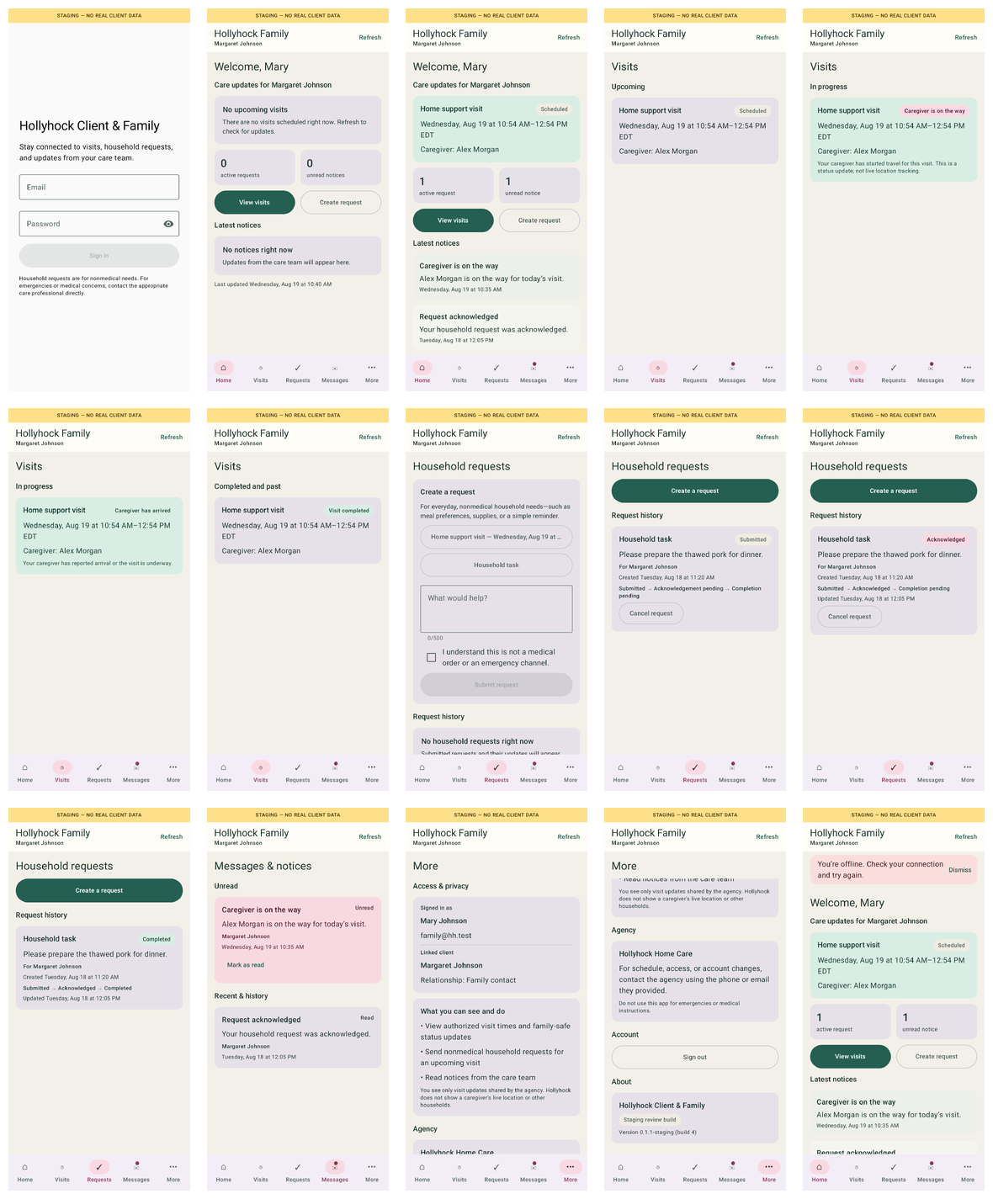
Client & Family reference: login, Home, Visits, Household Requests, Messages & Notices, More, privacy, and offline/error states.
27

Visits: Understand Status Without Live Tracking
1. Open Visits.
2. Choose the upcoming or recent visit you want to review.
3. Read the human visit status shown by the app — for example scheduled, caregiver on the way, in progress, or completed — as provided by the current release.
4. Use the caregiver name and local date/time shown on the visit card to confirm you are looking at the correct service.
5. If a visit status appears stale, refresh once. If it still does not match what is happening, contact the office rather than assuming the caregiver’s exact location.
6. Remember: visit status is not a live caregiver map and the family app intentionally does not expose raw GPS evidence.
28

Create and Follow a Household Request
1. Open Requests and choose Create a Request.
2. Choose the available request type/category or related visit/client context if the release asks for it.
3. Write a short, specific request. Use the office/emergency channels for urgent safety or medical emergencies.
4. Submit. Wait for the app to show the request as Submitted before leaving the screen.
5. Return to Requests to follow its state. Current family design uses clear human stages such as Submitted, Acknowledged, and Completed.
6. If the office asks a clarifying question through Messages, reply through the available communication method and keep the request itself focused on the requested work.
29

Messages & Notices
1. Open Messages.
2. Read unread notices first. Messages should use organization-local dates and times.
3. Open the complete message before acting on a schedule or service change.
4. Use the office’s normal contact number for urgent matters that cannot wait for in-app review.
5. If the app is offline, cached messages may remain visible with an offline banner. New information may not arrive until connectivity returns.
30

More: Access, Privacy, Account, About, and Offline Behavior
1. Open More.
2. Review Access & Privacy to understand which client the account is permitted to see and what the family app does not expose.
3. Open Account to confirm the signed-in email/person. Use Sign Out when the phone is shared or no longer controlled by the family member.
4. Open About for the app/release information when the office asks which version is installed.
5. When an offline/error banner appears, treat the displayed cached information as the last known state. Do not assume a visit has changed until the app reconnects and refreshes.
31

Office Walk-Through Script for a New Family User
This is the step-by-step office procedure for walking a client or family member through setup on their own Android phone.
1. Confirm the family member’s name, email, relationship, and the client they should be allowed to see.
2. Create/verify the family access grant in Hollyhock before touching the phone.
3. On the family member’s phone, open the approved download link and install Hollyhock Client & Family.
4. Have the family member enter the temporary credential/invitation and create their own password. Staff should look away while the person creates the permanent password.
5. Open Home and confirm the correct household/client.
6. Open Visits and explain the status language. State clearly: “This is visit status, not live caregiver tracking.”
7. Open Requests and demonstrate where a normal household request would be created. Do not create a fake live request unless the office intends to close it afterward.
8. Open Messages & Notices and show where schedule/service notices appear.
9. Open More → Access & Privacy and Account. Show Sign Out.
10. Ask the family member to close and reopen the app, then sign in once without staff assistance. The setup is finished when the person can get back to Home on their own.
Training finish line. Do not consider family setup complete merely because the APK installed. The family member should be able to sign in, identify the correct client, find Visits, create/find Requests, read Messages, and understand the privacy boundary.

Family setup acceptance checklist
Check | What the office confirms
[ ] | Home shows the intended household/client and agency name.
[ ] | Visits opens and the family member understands that status is not live caregiver tracking.
[ ] | Requests opens; the family member can explain how to create and follow a normal household request.
[ ] | Messages & Notices opens; the family member knows to call the office for anything urgent or unclear.
[ ] | More → Access & Privacy and Account are understood, including Sign Out.
[ ] | The family member can close the app, reopen it, and sign in without staff assistance.

When family access changes
1. Open the client and Family access & requests before creating anything new. Confirm which person currently has access and which client the grant belongs to.
2. If a family contact should no longer have access, use the authorized revoke/deactivate flow. Do not solve an access change by sharing another person’s login.
3. If a new family contact needs access, create or invite that person and attach only the intended client grant. Verify the relationship and email before sending the invitation.
4. If a phone is lost or replaced, follow the account/session recovery controls available in the current release. Do not give the family member an office or caregiver credential as a shortcut.
5. After any access change, have the family member sign in and confirm the correct household. Stop if the wrong client appears.
Privacy rule. Family access is client-scoped. A family account must never gain staff administration, caregiver clock/duty functions, payroll information, device-trust details, or another household merely because the person knows someone at the agency.

PART IV
Complete Operational Workflow
Use this section for training, acceptance testing, and handoff. It connects the office, caregiver, and family sides into one end-to-end visit without requiring anyone to understand the server internals.

32

New Client to Completed Visit — End-to-End
Step | Role | Action | Expected result
1 | Office | Create/convert client | Client exists in correct office.
2 | Office | Add service location and verified pin | Correct address/pin/radius saved.
3 | Office | Create visit | Visit has client, location, start/end, service.
4 | Office | Assign/publish caregiver | Visit appears in caregiver My Day.
5 | Caregiver | Prepare visit / Start Approach | Travel awareness active for correct visit.
6 | Caregiver | Arrive and recheck | App recognizes/handles arrival state.
7 | Caregiver | Clock In | Clear on-duty/clocked-in state.
8 | Caregiver | Provide care / document work | Tasks/notes/requests/messages handled as required.
9 | Caregiver | Clock Out | Visit ends; completion/time event saved.
10 | Office | Review Schedule / GPS Review / Hours | Final visit state, evidence, exceptions, and derived hours are consistent.
11 | Family | See appropriate visit status | Understandable status only; no raw GPS/payroll/device internals.
12 | Office | Approve/export when ready | Only accepted/eligible hours move to the next business process.

Acceptance standard. The workflow is complete when the caregiver can finish an authorized visit and the office can review the resulting visit, GPS/exception state, and hours. A pretty login page is not an operational acceptance test.

33

Corrections and Exceptions: Preserve the Original Record
Hollyhock is designed around reviewable states. When reality differs from the schedule or an automated decision, the correct response is a documented exception/correction — not deleting evidence until the screen looks cleaner.
• Wrong time: use the authorized clock correction with reason and reviewer.
• Wrong/missing arrival evidence: review GPS/visit evidence and use the approved exception path.
• Caregiver at an approved alternate location: document the legitimate location reason; do not move the client home pin to match the phone.
• Missed clock-in: confirm care was actually delivered, gather the required facts, and use the authorized fallback/correction process.
• Duplicate user tap: check current state before trying again. A rejected duplicate is different from a missing event.
• Schedule was wrong: correct the schedule/assignment record and document why; do not force a GPS decision to compensate for a bad schedule.

PART V
Troubleshooting, Privacy, and Quick Reference
Most user problems are one of five things: wrong account/office, wrong visit or assignment, phone readiness/location, network/sync delay, or a legitimate review exception. Start with the layer that failed. Do not reset passwords, reinstall apps, or edit visit data until you know which layer is wrong.

T-01

User Cannot Sign In
1. Confirm the email address is the one on the Hollyhock account.
2. Confirm the person is using the correct application: Administrator web, Caregiver app, or Client & Family app.
3. Use the approved password-reset/invitation process if the password is forgotten.
4. If login works but the wrong office/client appears, stop and fix role/office/family access mapping. Do not create a duplicate account as the first fix.
T-02

Android App Will Not Install
1. Confirm the APK came from the customer’s approved Hollyhock download page.
2. Allow Chrome to install from this source only when Android prompts for the approved package.
3. Use the Play Protect “More details / Install anyway” path only after confirming it is the approved Hollyhock build. Do not turn Play Protect off globally.
4. For an update, install over the existing app when the release instructions say same-signer update. Do not uninstall as a routine troubleshooting step.
T-03

Caregiver Cannot See the Visit
1. Refresh My Day.
2. Have the office open Schedule and confirm the visit is assigned to that caregiver, published, in the correct date/time window, and in the caregiver’s authorized office.
3. Check whether the visit was cancelled, reassigned, or left as a draft/open shift.
4. Fix the schedule/assignment first. Reinstalling the app does not repair a visit that was never assigned.
T-04

Location / Approach / Arrival Is Not Working
1. Open More → Phone readiness. Confirm location services and background activity are acceptable.
2. Confirm Android’s date/time are correct and the phone has location enabled.
3. Confirm the caregiver opened the correct scheduled visit.
4. Have the office confirm the service-location pin and approved radius/policy.
5. Recheck once when physically at the correct service location.
6. If the app shows Approach-only/no clock-in, use the full visit/arrival action. If still blocked, preserve the state and contact the office for review instead of manufacturing a clock event.
T-05

Clock In or Clock Out Is Pending / Interrupted
1. Do not repeatedly tap the button while Hollyhock shows sending/pending.
2. Check network service. Keep the app installed and keep local state intact.
3. Reopen the active visit and read the current state before trying any action again.
4. If the state cannot complete, contact the office. The office can review evidence/corrections; uninstalling or clearing data can destroy the best troubleshooting evidence.
T-06

Family App Shows No Client / Wrong Client
1. Sign out and confirm the email being used.
2. Have the office open Family Access and confirm exactly one intended active client grant for that identity.
3. Correct the grant. Do not give the family member a staff/caregiver account as a workaround.
4. Sign in again and verify Home/Visits show the correct household.
T-07

Household Request or Message Seems Missing
1. Refresh once and check network connectivity.
2. Confirm the user is in the correct client/office context.
3. Check the request/message state and date filters on the office side.
4. If offline, wait for sync rather than creating repeated copies of the same request.
5. Use the office phone/emergency process for urgent matters rather than waiting on an uncertain in-app state.
T-08

Hours or Corrections Do Not Match the Visit
1. Open the visit and inspect the original clock-in/clock-out evidence.
2. Open Hours & Review and inspect pending exceptions/corrections.
3. Confirm the date range, office, caregiver, and approval state.
4. Use an authorized correction with a reason. Do not delete or overwrite the original evidence.
5. After approval, re-run the report/export view and confirm the expected eligible hours.
34

Privacy and Capability Matrix
Information / action | Admin / Office | Caregiver | Client & Family
Agency dashboard / all office work | Yes, if authorized office | No | No
Leads / consultations | Yes | Normally no | No
Client record | Yes | Assigned/authorized subset | Linked client subset
Schedule | Office scope | Own assigned work | Visit status for linked client
Raw CARE-GPS evidence | Reviewer/admin when authorized | Own workflow result, limited technical detail | No
Clock in/out | Review/admin correction | Own authorized visit | No
Own hours | Review/approve | Own records when enabled | No
Finance/payroll | Only role-granted staff | No | No
People / roles | Authorized admin | No | No
Household requests | Review/manage | See/action when authorized | Create/follow linked requests
Device trust / enrollment | Authorized admin/technical view | Own readiness summary | No
Other clients / caregivers | Office-role dependent | No | No

35

Training Sign-Off
Use this checklist for initial customer training or a new employee/family onboarding. “PASS” means the person completed the action, not that the trainer demonstrated it for them.
Role / skill | PASS | Notes
Admin: sign in and choose correct office | [ ]
Admin: create/convert client | [ ]
Admin: set/verify service-location pin | [ ]
Admin: create, assign, publish visit | [ ]
Admin: invite/manage caregiver | [ ]
Admin: create family access | [ ]
Admin: review GPS / exception | [ ]
Admin: review hours / correction | [ ]
Caregiver: phone readiness | [ ]
Caregiver: Start Approach | [ ]
Caregiver: arrival / Clock In | [ ]
Caregiver: Clock Out | [ ]
Caregiver: requests/messages | [ ]
Family: install/sign in | [ ]
Family: Visits / privacy boundary | [ ]
Family: create/find request | [ ]
Family: Messages / More / Sign Out | [ ]

Agency / Customer: ____________________________________ Trainer: __________________________
Training date: __________________ Release: __________________ Office: __________________

QUICK START

Caregiver — One Page
• Before work: Open Hollyhock → More → Phone readiness. Location, alerts, and background activity must be acceptable.
• My Day: Open the assigned visit; confirm client, time, and location.
• Travel: Tap Start Approach when you actually begin traveling. Keep the phone with you; do not force-stop the app.
• Arrival: At the service location, recheck/confirm arrival if asked. Use the full visit path, not Approach-only, for clock-in.
• Clock In: Tap once and wait for a clear On Duty / Clocked In state.
• During visit: Complete required tasks/notes; review Requests/Messages as needed.
• Clock Out: Finish documentation → Clock Out → wait for Completed/Off Duty state.
• Problem: Do not clear app data or reinstall first. Read the current state, refresh once, then contact the office with the visit/time and what the screen says.
Emergency. Hollyhock is an operations tool, not an emergency service. Use 911 and the agency emergency process when required.

QUICK START

Administrator / Office — One Page
• Start: Overview → today’s schedule → open/call-off visits → overdue follow-ups → notifications.
• New client: Lead/Client → service location → verify pin → save.
• Visit: Schedule → create draft → client/location/time → assign caregiver → publish.
• People: Invite → office/role → caregiver readiness → confirm accepted account.
• Family: Create client grant → invite → verify linked client; no staff/caregiver capabilities.
• Exceptions: GPS Review → inspect visit/evidence → approve/deny/correct with reason; never erase raw evidence.
• Hours: Resolve exceptions/corrections → approve eligible hours → report/export only after review.
• Mobile: Distribute approved Caregiver / Client & Family packages from customer Hollyhock, not random APK copies.

QUICK START

Client & Family — One Page
• Install only from the link supplied by the care office.
• Sign in with your own email/password. Confirm the correct household on Home.
• Visits: See understandable visit status and schedule information. The app is not a live caregiver map.
• Requests: Create a normal household request → submit → follow Submitted / Acknowledged / Completed.
• Messages: Read notices and office communication. Call the office for urgent matters.
• More: Review Access & Privacy, Account, About, and Sign Out.
• Offline: Cached information may remain visible; new status may not appear until the app reconnects.

MANUAL CLOSEOUT

What “Operationally Ready” Means
A customer is not ready because every user can see a login screen. Hollyhock is ready for normal operation when administrators understand office scope and scheduling, caregivers can complete the approved visit workflow from Approach through Clock Out, family users can operate their restricted client view, exceptions can be reviewed without destroying original evidence, and the office can reconcile the visit into hours/reports with no mystery states.
Final standard. The software should be understandable to the people who operate it. A competent office user, caregiver, or family member should be able to follow this manual, see the expected result, and know when to stop and ask for help instead of guessing.

Coal Road Productions • Hollyhock Developer Pack • User & Operations Manual • Version 1.0 • October 2026

